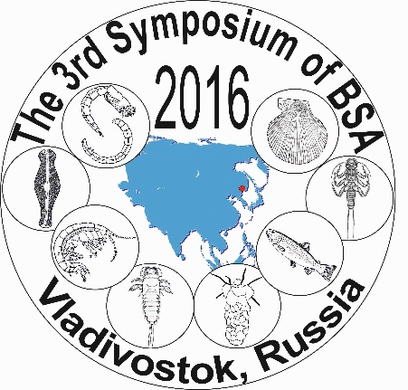 | BSA–2016  The 3rd Symposium of  the Benthological Society of Asia  24–26 August, 2016 – Symposium  27–30 August, 2016 – Youth Freshwater Ecology School  Vladivostok, Russia

REGISTRATION FORM
Please complete and return to:
E-mail: BSA-2016@biosol.ru Web: www.biosoil.ru/BSA2016

The Registration period: 01 December, 2015 to 30 April, 2016

The early bird Registration fee payment: 01 January, 2016 to 31 May, 2016

The submission of Abstract: 01 December, 2015 to 31 May, 2016

Phone: +79242408457; +79025249745; +74232310718

Fax: +74232310193

E-mail: BSA-2016@biosoil.ru

A separate registration form must be used for each participant!

Section A. Personal Information
Title |  Prof.  Dr.  Mr.  Mrs.  Ms.  Other:
First Given Name
Middle Given name
Family name
Affiliation (Institution)
Address
City, State, Zip Code
Country
Phone No |  | Fax No
E-mail(s)
Accompanying Person |  Mr.  Mrs.  Ms. Family name: Given Name:
Accompanying Person |  Mr.  Mrs.  Ms. Family name: Given Name:

Section B. Presentation
Presentation Title
Type of Presentation | Oral | Poster
Name of Section¹
Necessary equipment
¹Please choose from among the following General Sections:
- Freshwater Biomonitoring and Bioassessment
- Biodiversity and Conservation (Subsection: Algae, Worms, Mollusks, Crustacea, Aquatic Insects, Other Invertebrate Groups, and Fish)
- Evolution and Systematics
- Community Structure and Dynamics
- Aquatic Ecosystem Modeling and Management
- Behavior and Physiology
- Molecular Biology and Genetics
- Lower Parts of Rivers, Estuaries
- Marine Ecosystems

Section С. Registration Fee
Category | Early bird registration fee,  before 31 May, 2016 | After 31 May, 2016  up to symposium date
Full delegate, member of BSA | 250 usd | 300 usd
Full delegate, non-member of BSA | 250 usd | 300 usd
Student², member of BSA | 125 usd | 175 usd
Student², non-member of BSA | 125 usd | 175 usd
Accompanying Person | 120 usd | 170 usd
²«Students» include all persons who are undergraduate students, bachelors, postgraduates.
Fee for Delegates and Students includes:
1. Transfer from airport.
2. Admission to all scientific sessions.
3. Program and abstract book.
4. Coffee/tea breaks.
5. Welcome reception.
6. Banquet.
Fee for Accompanying Person includes:
1. Transfer from airport.
2. Coffee/tea breaks.
3. Welcome reception.
4. Banquet.

Section D. Participation in Youth Freshwater Ecology School
River Water Quality Assessment | Participation
Biological methods (Periphyton, Benthic Macroinvertebrates) | Yes | No
Bacteriological methods | Yes | No
Chemical methods | Yes | No
All urgent communications connected with organization issues: vshivkova@biosoil.ru and nikulina@biosoil.ru

Information about method of payment and other necessary information will be posted in the Second Circular Letter.

